

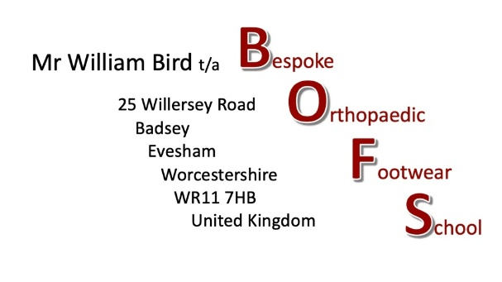

The Pattenmakers’ Certificate in Bespoke Orthopaedic Footwear
October 2026 – August 2028
Open for applications, April 1st, 2026.

Title
Forename (s)
Surname
Address
Postcode
E mail address
Are you a UK Resident? (Y/N)
Employment Status (Full time/Part time/Student/ Unemployed)
Name of Current Employer or College and Address
Length of service/ course
Job title and brief description of role or details of course being studied.

For all Applicants
1/ Do you have access to a workshop or facility with stitching machinery (Y/N)
2/ Do you have access to Zoom/TEAMS (Y/N)
3/ Are you able to attend an annual face to face training weekend held in the UK in February/March Y/N
4/ Are you self financing? - Tuition fees are £600 per term - 6 terms (Y/N)
5/ Are you looking for financial support from The Worshipful Company of Pattenmakers to cover tuition fees? (Y/N)
* Support is only available to UK Residents
Please give a short resume as to why you are applying and what makes you a suitable student for this course.
Signed |  |  |  |  |  |  |  |  |  |  | Date
Please e mail the completed form by the 30th April 2026

