

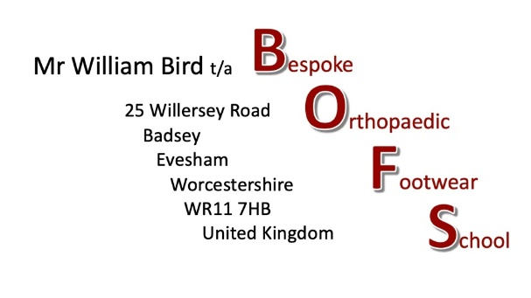

The Pattenmakers’ Certificate in Bespoke Orthopaedic Footwear
October 2026 – August 2028
Open for applications, April 1st, 2026.

This is not an academic course but a high-level vocational course using everyday language to teach hands-on practical shoemaking skills.

The course is intended for people who have at least some basic skills in shoemaking and who want to learn new skills and to develop the skills they already have to help clients with fitting and walking difficulties. The course is for those who would like to become Bespoke Orthopaedic Shoe and Boot Makers

As an applicant, you will be expected to have a basic knowledge of shoemaking with rudimentary experience in hand-lasting and the cemented construction of soles and heels. These skills, as well as your closing and pattern-making skills, will be developed during the course, as will your ability to modify existing lasts to the measures you will learn to take.

You will need to have a set of hand tools, access to upper leathers, material for building soles and heels and associated grindery. A leather sewing machine with a presser wheel - preferably a post machine - is also an essential requirement. The on-line sessions are for two hours per week during term time but you will also need to set aside at least five additional hours a week to study and to do the hands-on course work tasks.

The course follows chapters, delivered on a weekly basis, which build into a 900-page, full colour comprehensive set of textbooks that are unique to the course and are yours to own. These can either be printed as a whole, in part, or kept as a digital copy. During the course you will receive video commentaries on each of the 60 chapters in the books.

The course will run from October 2024 with ten online sessions per term, finishing in August 2026. It will be run on Zoom and there will be no more than twelve students per cohort.
The six terms over the two years will consist of 60 double sessions overall. Each weekly Zoom session will consist of a theoretical session followed by a practical session.

The fees for the course will be £600 (plus VAT) per term, payable in advance by the beginning of each term.

There are a limited number of full and half bursaries for UK students. Please state your interest in this, with your enquiries.

Subjects covered in the course will include:

- Understanding and learning to assess the dynamics of the human gait cycle.
- Anatomy and physiology of the lower leg and feet, presented so as to be useful for shoemakers.
- The physiology and possible pathologies of the Circulatory System, the Peripheral Nervous System, the Integumentary System (Skin) and the Musculoskeletal System.
- The conditions that develop when things go wrong with the feet and, importantly, the types of styles and specifications that work for those conditions.
- Methods of measuring and assessing your clients and how to develop footwear treatment plans.
- Pattern-making and tweaking designs for maximum elegance.
- Closing skills.
- Techniques for modifying lasts.
- Profiling soles and heels to assist the gait of the wearer.

And many more.

The theoretical session will be live with Bill Bird and will show a video recording by either Bill, Phil Stewart, Hartmut Seidich, Lisa Sorrell or Marcel Mrsan (all well-recognised educators in footwear design and making), giving a commentary on the current chapter. The chapters will be sent during the week before the session so that you can read the material as many times as you want so that any questions you might have can be answered during the live session. The theoretical content has been especially written and illustrated for practically minded shoemakers.

The practical sessions in the first year will consist of hands-on technical exercises. A size two model last will be posted to you at the beginning of the course for you to use during these sessions. Some of these exercises will be building up your closing skills and most will relate to putting into practice an aspect of the theoretical session. You will be building up a portfolio of your work during the course as well as a photographic portfolio for you to send in for assessment and advice.

During the first year, you will make patterns and uppers for a bagged court shoe, a soft lace shoe, a Derby shoe, and Oxford shoe and a ¾ strap court shoe. You will last up at least two of those and build on the soles and heels.

At the beginning of the second year, a size two model last with one of five variations of orthopaedic problems will be posted to you. During this year you will be working through a core bespoke orthopaedic project that will give you the chance to explore and create a pair of bespoke orthopaedic shoes using the full scope of what you will have learned. During the second year you will also make up an anchor trainer and a hiking/fell boot with bellows tongues.

Throughout the two years of the course, your practical work will be assessed, and you will have regular short tests to answer that will ensure you are understanding the theoretical work.

Students will need to have passed Year One of the course to gain access to Year Two. At the end of Year Two, your work will be assessed by a small team of skilled footwear design educators. Those who reach a Merit or Distinction Standard will receive their Pattenmakers Certificate in Bespoke Orthopaedic Footwear from the Worshipful Company of Pattenmakers, the ancient London livery company that takes a special interest in Bespoke Orthopaedic Footwear.

Please find the details needed for your application on the following page.

Bill Bird BSc, Cert Ed, MSSF

Application.

Please complete the application form.

A copy of your CV and educational qualifications

A brief description of your educational experience with respect to shoemaking.

Your reasons for wanting to do this course.

Please send applications to:

Email: comms@pattenmakers.co.uk & billbird52@gmail.com

Post: William Bird
Bespoke Orthopaedic Footwear School
25 Willersey Road
Badsey
WR11 7HB
UK

