Young Pattenmakers’ Annual Dinner
Friday 14th November 2025
Butchers’ Hall, 87 Bartholomew Close, London EC1A 7EB

Host Name:
Company Name:
Special dietary requirements:
Drink preference: alcoholic non-alcoholic
E-mail:

I require ___ number of tickets at £65 (£65 for under 40s and £135 for over 40s each (incl. VAT)
Attending Guest(s)

Name:
Company Name:
Special dietary requirements:
E-mail:
Drink preference: alcoholic non-alcoholic
Name:
Company Name:
Special dietary requirements:
E-mail:
Drink preference: alcoholic non-alcoholic
Payment
Payments by electronic bank transfer should be made to:
Acc. Name: Pattenmakers Events Ltd
Sort code: 40-04-09
Acc. No.: 71828924
Please use your name and the event date [ 14/11/2025] as payment reference

Form Submission
Please return this form electronically to: assistantclerk@pattenmakers.co.uk
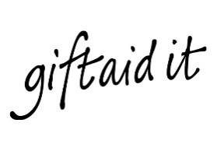
If you have any queries, please contact Assistant Clerk.at the above email address or by calling 07875 282211

