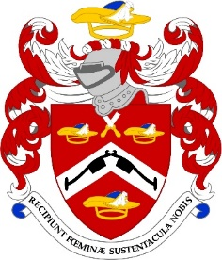

The Common Meal Booking Form

THURSDAY, 11th SEPTEMBER 2025
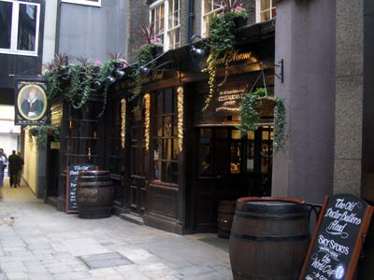

Venue: The Old Dr Butler’s Head
2 Masons Avenue, Moorgate, London, EC2V 5BT
Time: 6:30pm
(the evening is limited to 30 people so please book early)

Dress Code: Lounge Suit

NAME ………………………………………………………………..…

I have paid on line ...... or paying by bank transfer

(please quote your name and the event if paying by bank transfer)

Pattenmakers Events Limited
HSBC
Sort code 40-04-09
Account number 71828924

Dietary requirement ……………………………………………………

Please note tickets are not usually sent out but if you want to bring a potential member please let me know and I will send a card pour memoire

