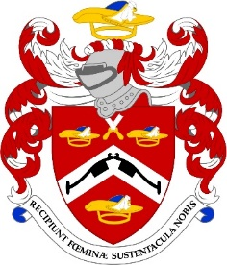
Common Hall, Election of Lord Mayor
Monday, 29th September 2025 Guildhall
For the past several centuries, the Livery have been summoned to Guildhall for a Common Hall twice yearly; once, to elect the Lord Mayor (on Michaelmas Day) and once to elect the Sheriffs (on Midsummers’ Day, 24 June).
Both Common Halls tend to be very popular events and seating is provided on a first-come-first-served basis, so early arrival is recommended. Passes are issued to Clerks, who in turn provide them to eligible Liverymen on request, and these will need to be shown on entry to the Guildhall to prove your right to attend. Spouses or guests who are not Liverymen cannot attend Common Hall but are very welcome to attend the subsequent Luncheon!
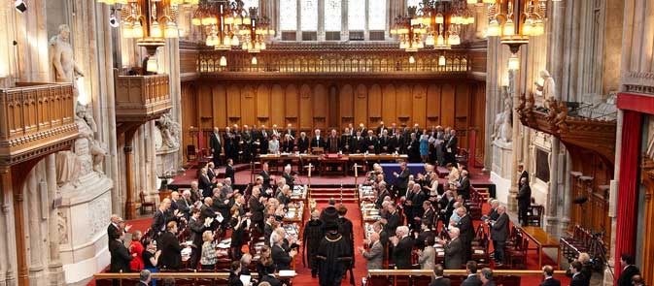
Luncheon has been arranged in the Guildhall Club, three courses, wines and Port at a cost of £85.00per person and can be booked on the website or sending in the booking form HERE.
AND not to confuse with the Common Meal!
NAME (S) ………..………………………………………………………..…
Pattenmakers Events Limited
HSBC
Sort code 40-04-09
Account number 71828924
Dietary requirement (s) ……………………………………………………

Please confirm where you would like your Pass sent

