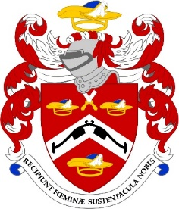

THE COMMON MEAL

THURSDAY, 11th SEPTEMBER 2025

In the early days of the Livery, at least from the 17th Century if not before, it was the custom to hold a Common Meal for the entire Livery after a meeting where ‘ordinary business’ was conducted. Officials were elected and new ‘brethren’ were admitted. Widows petitioned for pensions and the Court had to explain where the money had gone.

It is reputed by ancient tradition that following a Common Meal in the early 18th Century, that having vacated “an inne or taverne in ye Citee” the Pattenmakers confronted the Lord Mayor’s Parade on Lord Mayor’s day and blocked the way. Legend has it that one of my predecessors and the then City Marshal agreed that the Pattenmakers would withdraw allowing the parade to pass on the condition that every third year the Pattenmakers’ Company would have a carriage in the Civic procession ahead of the Great
Twelve Companies.

Today, the Common Meal follows a meeting of the Finance and General Purposes Committee who transact ‘ordinary business’. The Common Meal is now an informal meeting to which all Company members are invited to hear about some of the key strategies of the Company and more importantly, to give those members the opportunity to question and have clarified any Pattenmaker matters and to make suggestions to improve how we operate.

This year the Common Meal will be at
The Old Dr Butler’s Head
2 Masons Avenue, Moorgate
London
EC2V 5BT
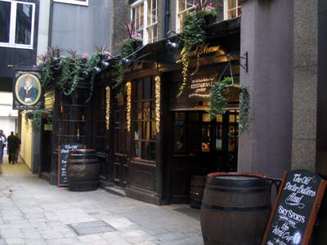
The pub takes its name from one Dr Butler, a 17th-century self-proclaimed specialist in nervous disorders. His 'miracle cures' included holding consultation on London Bridge, during which the unfortunate client would be dropped through a trapdoor into the torrent below.
As a cure for epilepsy, he would fire a brace of pistols near his unsuspecting patient, to “scare the condition out of them”. In cases of the plague, he’d plunge the poor soul into cold water.
So highly was he considered, that despite his lack of qualifications he was appointed court physician to King James I.
Around that same time, he developed a medicinal ale for gastric ailments, which was available only from taverns which displayed Dr. Butler's head on their signs. This led to him acquiring a number of ale houses in the capital - of which The Old Dr. Butler's Head is the last one standing.

The Common Meal is open to Freemen and Liverymen only and is a great opportunity to meet other members. It endorses one of the key tenets of the Livery through the ages - Fellowship and Friendship!

Please join us from 6.30pm for dinner at 7.00. Cost £45.00 a head which covers the 3 course meal and half a bottle of wine. Dress, lounge suit.

The evening is limited to 30 people so please book early.

With best regards

Robert

NAME ………………………………………………………………..…

I enclose my cheque for ……………… or I have paid on line ...…

(please quote your name and the event)

Pattenmakers Events Limited
HSBC
Sort code 40-04-09
Account number 71828924

Dietary requirement ……………………………………………………

Please note tickets are not usually sent out but if you want to bring a potential member please let me know and I will send a card pour memoire

