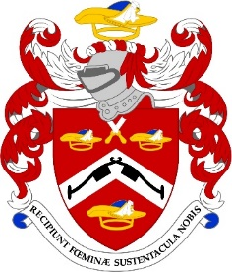
Worshipful Company of Pattenmakers
Calendar of Events 2025- 27
EVENT | DATE | LOCATION
Common Meal | 11 September 2025 | Old Dr Butler’s Head
Sheriff’s Chain | 22 September 2025 | Fishmongers’ Hall
FM/BE Dinner | 22 September 2025 | Barber Surgeons’
Sheriffs’ Admission | 26 September 2025 | Guildhall
Common Hall Election | 29 September 2025 | Guildhall
October Livery Dinner | 23 October 2025 | Cutlers’ Hall
Masters & Clerks | 5 November 2025 | Armourers’ Hall
Lord Mayor’s Show | 8 November 2025
Remembrance Day | 9 November 2025
YP Dinner | 14 November 2025 | Butchers’ Hall
Carol Service | 18 December 2025 | St Margaret Pattens
Court & Stewards Dinner | 8 January 2026 | t.b.c.
Annual Banquet | 23 January 2026 | Mansion House
March Dinner | 11 March 2026 | Merchant Taylors
United Guilds Service | 20 March 2026 | St Paul’s & Stationers
Footwear Dinner | 7 May 2026 | Ironmongers’ Hall
Master’s Weekend | 16\17 May 2026 | Somerset
Common Hall Election | 24 June 2026 | Guildhall
July Dinner | 2 July 2026 | Apothecaries’ Hall
Common Meal | 10 September 2026 | CLC t.b.c.
FM/BE Dinner | 7/14 September | Salters’ Hall
Sheep Drive | 27 September 2026
Common Hall Election | 29 September 2026 | Guildhall
October Dinner | 15 October 2026 | Grocers’ Hall
Masters & Clerks | 5 November 2026 | Armourers’ Hall
YP Dinner | 27 November 2026 | Saddlers’ Hall
Carol Service | 17 December 2026 | St Margaret Pattens
Court & Stewards | 7th January 2027 | TBA
Annual Banquet | 29 January 2027 | Mansion House
March Dinner | March 2027 | TBA

