To All Pattenmakers 24th November 2023

CAROLS & CHRISTMAS DINNER – THURSDAY, 14th NOVEMBER 2023

Master Pattenmaker, Commodore Pat Tyrrell, is delighted to invite you to the Company carol service at St Margaret Pattens church, followed by a festive dinner at Davy’s at Plantation Place, Mincing Lane, EC3R 7BD.

The service begins at 6pm.

The cost of the three-course festive dinner is £65 including wine and service charge. Dinner will be served at 19:30 and is a short walk from the church.

If you wish to attend the carol service, dinner or both, please complete and return the attached form to me as soon as possible.

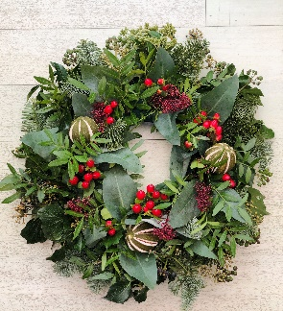

With kind regards

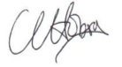
Claire Hobson, Clerk desig.

Please complete the following booking form and return to:
By email (preferable): claire@pattenmakers.co.uk
By post: 4 Sheridan Close, Hemel Hempstead, Herts, HP1 1Xs
01442 393916 / 07432 611362

Name:
Guest(s):
I/we wish to attend: | Carol service |  | Dinner
Dietary requirements

Dinner tickets are £65 per person, which includes a three-course festive meal, wine and service charge.

Please pay by Electronic Bank Transfer:

Pattenmakers Events Limited
HSBC Sort code 40-04-09
Account number 71828924

Important! Please put reference: name141223 (eg ClaireHobson141223)

NB: Tickets are not issued for this event

