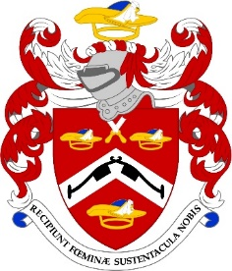

This year the Common Meal will be at:
Davy’s at Plantation Place
Plantation Lane Mincing Lane,
London EC3R 7BD
020 7621 9878

The Common Meal is open to Freemen and Liverymen only and is a great opportunity to meet other members. It endorses one of the key tenets of the Livery through the ages - Fellowship and Friendship!

Please join us from 6.30pm for dinner at 7.15. Cost £65.00 a head which covers the 2 course meal and half a bottle of wine

The evening is limited to 30 people so please book early.

With best regards

Robert

NAME ………………………………………………………………..…

I enclose my cheque for ……………… or I have paid on line ...…

(please quote your name and the event)

Pattenmakers Events Limited
HSBC
Sort code 40-04-09
Account number 71828924

Dietary requirement ……………………………………………………

Please note tickets are not usually sent out but if you want to bring a potential member please let me know and I will send a card pour memoire

