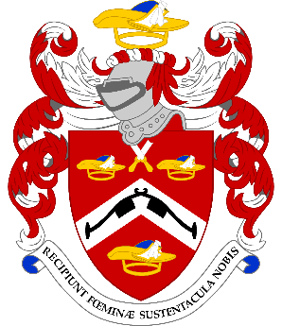
REQUEST FOR BOOKING

Dinner at HM Tower of London – 18th April 2023 - 18.45 for 19.15

Dinner will be at the Fusilier Mess. The Fusilier regiment was raised at the Tower of London in 1685.

We are honoured to be able to welcome the Deputy Governor of HM Tower of London, Commander Debra Whittingham, as our guest speaker.

This is expected to be a very popular event. Attendance will be limited to only one guest and tickets will be allocated on a first come first served basis.

To: Assistant Graham Perry, Events Committee Chairman
events@pattenmakers.co.uk

Name............................................................................................................. Post Nominals ...................

I have the following dietary requirement(s) ……..........................................................................

I wish to attend alone/with the following guest and I have made an online payment for

£.......................... in payment for Qty ......................... invitations at £120.00 per person.

I have paid by Electronic Bank Transfer:

(please quote your name and date of event)
Pattenmakers Events Limited
HSBC
Sort code 40-04-09
IBAN: GB26HBUK40040971828924 BIC: HBUKGB4106D
Account number: 71828924

Name of Guest ............................................................................................................................
Dietary Requirement .............................................................................................................................

Notes. 1. Unfortunately, we are not able to confirm if it will be possible to attend the Ceremony of the Keys after dinner, this will only be done closer to the date and depending on availability of space.
2. Dress code for this event will be Black Tie.
3. Photographic ID will be required for access to the venue.

PLEASE RETURN THIS FORM TO GRAHAM PERRY
[BEFORE 10th April 2023]
Sadly we will not be able to refund cancellations after this date

