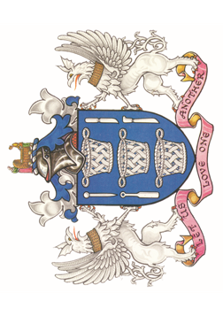
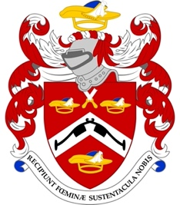

The Friends of St Margaret Pattens Church

Welcome to our Church
St Margaret Pattens has been a place of worship and a resource for the community since 1067, a year after the Norman invasion. The current Church was built by Sir Christopher Wren following the destruction of the previous Church in the Great Fire of 1666 and remains largely unaltered to this day.

The Livery Companies of the Basketmakers and Pattenmakers have been long time supporters of the Church and this is demonstrated in the recording of Masters within the panelling of the Church and in the stained glass windows. Many members of the Friends are associated with these two ancient Livery companies and this relationship is much cherished.

Why become a Friend?
The Friends was set up as a separate charity to support this ancient and distinguished church building for future generations, to help keep the church open and to continue to make it accessible for everyone today.
As a registered charity (no 1062360) with a Board of Trustees, the Friends discharge the above aims by making grants for the ongoing life, fabric and contents of the Church. This is only possible due to the contributions of those who commit to regular payments as Friends as there is no endowment from which we can draw.
Please join us for as a Friend you will be contributing to the Church’s future, be kept up to date through our Friends’ newsletter and be able to join our special events for the Friends.

How to become a Friend
We want to make things as easy as possible to become a Friend. All you need to do is set up a standing order with your bank through their app for a regular payment. Most people are paying £25 each quarter, but £100 or more annually is equally welcome. The bank details you need are:
Sort Code 20-20-14
Account No 80162957
Account Name Friends of St Margaret Pattens Church

Please advise jamie.ingham_clark@btinternet.com when you have done so, then we can record your interest and look out for your payment. If you are a taxpayer you can use this address to advise you wish giftaid* to be reclaimed on our payment.

For ease of administration, information about membership of the Friends will be managed and stored by the Church on its systems. Please inform us if you do not agree to this.

We look forward to you having a long and fruitful association with the Friends and the Church we all support. Thank you for your interest.

*GiftAidit. You would like tax to be reclaimed on your donation and any future donations under the Gift Aid Scheme. You are a UK taxpayer and understand that if you pay less income tax and or capital gains tax than the amount of Gift Aid claimed it will be your responsibility to pay the difference.

