- When you have clicked on one of the links in the YP gift donation flyer, either for the children’s wishlist or women’s wishlist, you may be asked to “allow” visiting the webpage associated with the link. Please click “allow” and the amazon wishlist webpage will open.
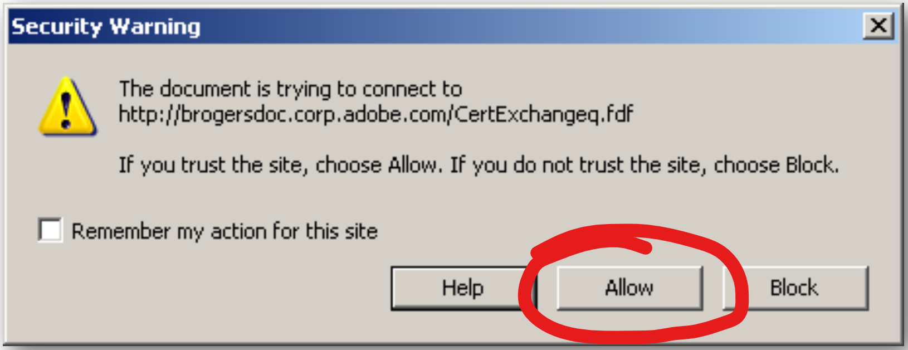
- If, for example, you clicked on the children’s wishlist link, the webpage that opens will look something like the below image:
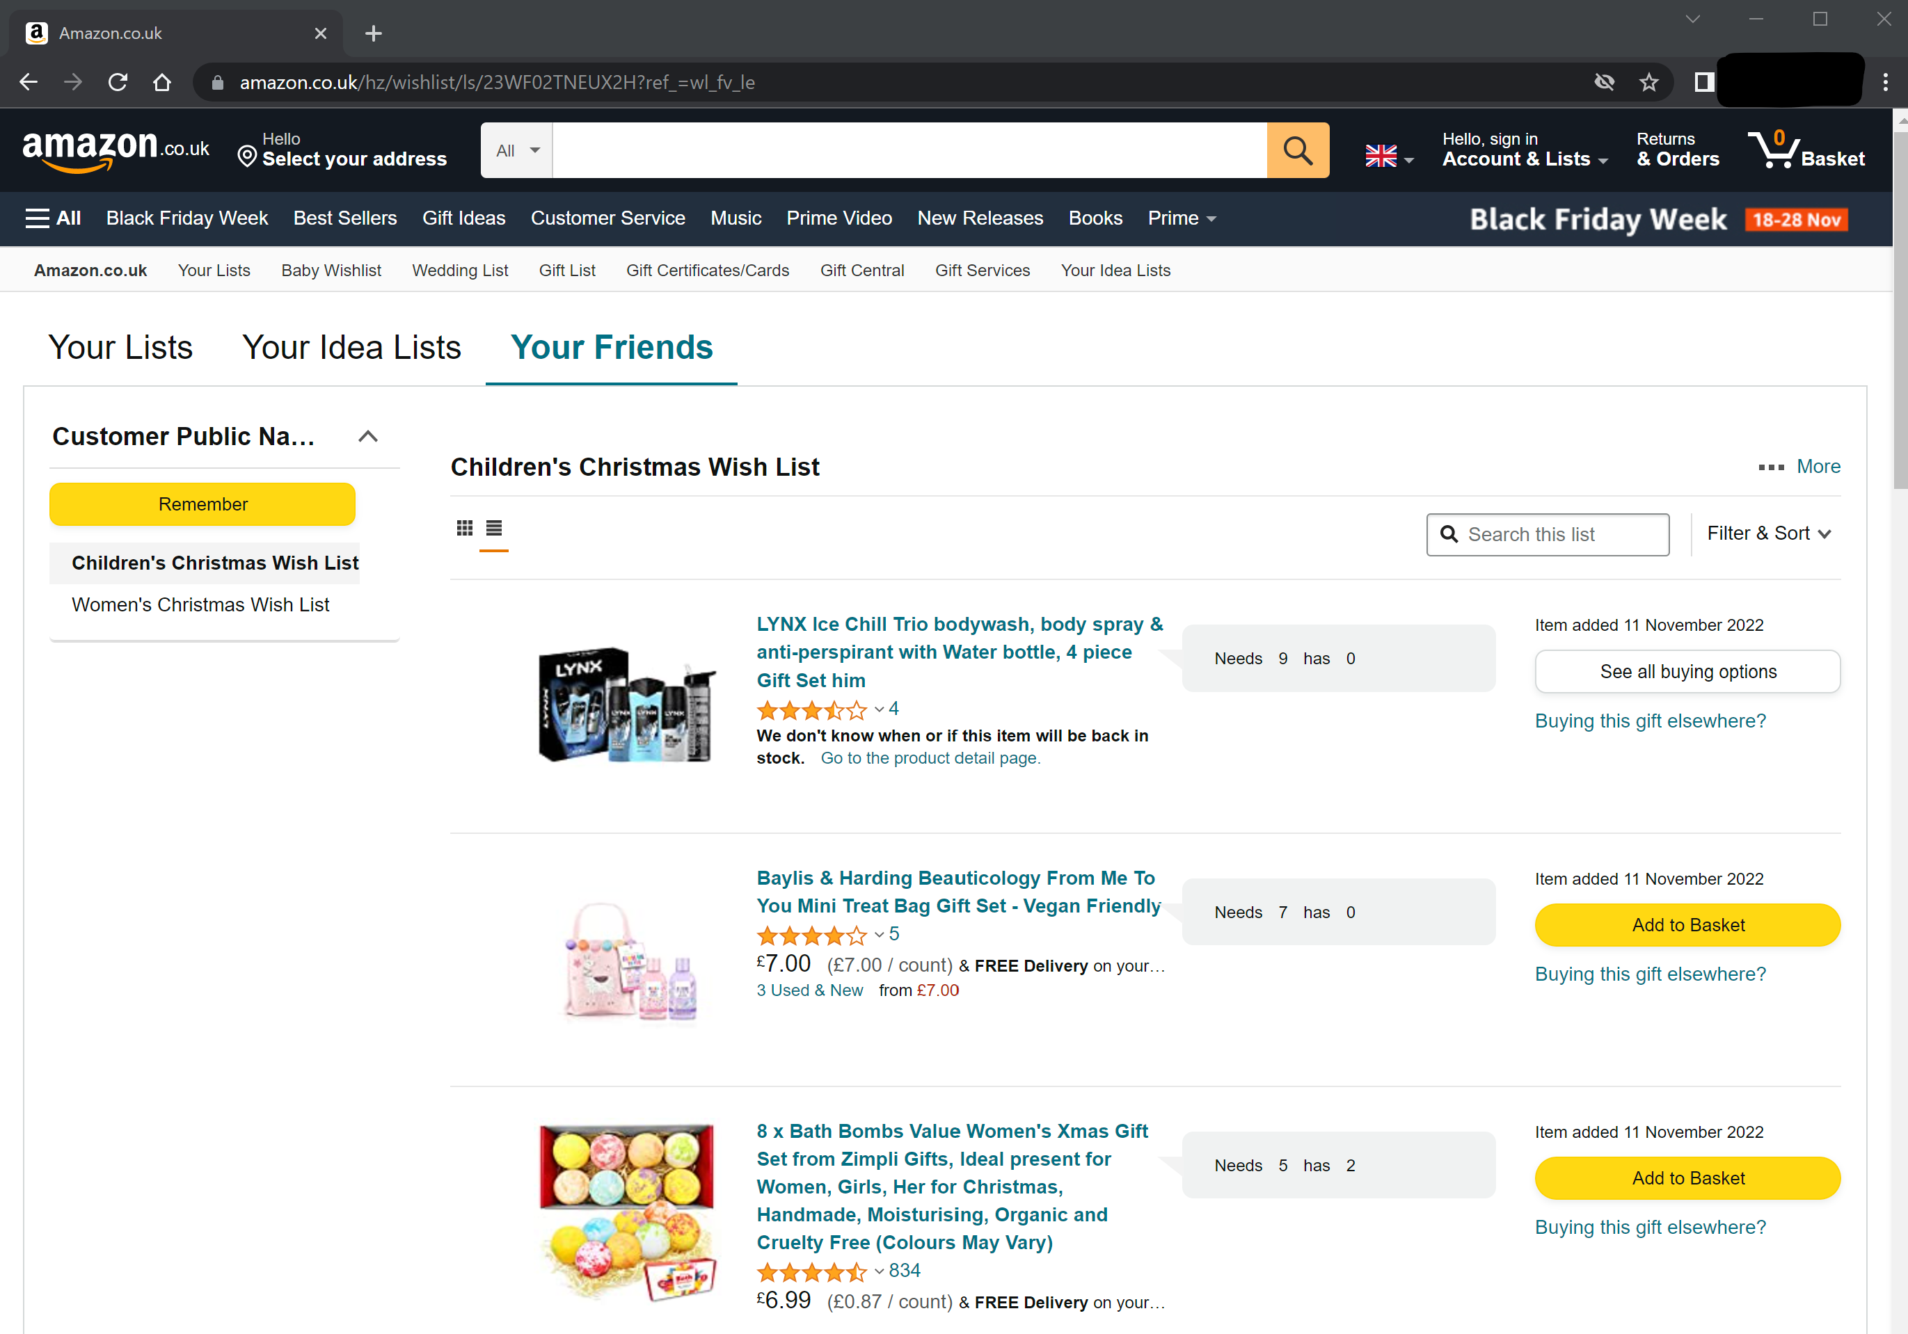
- For convenience, you can access both wishlists on the left side of the webpage underneath the yellow button that says “Remember”
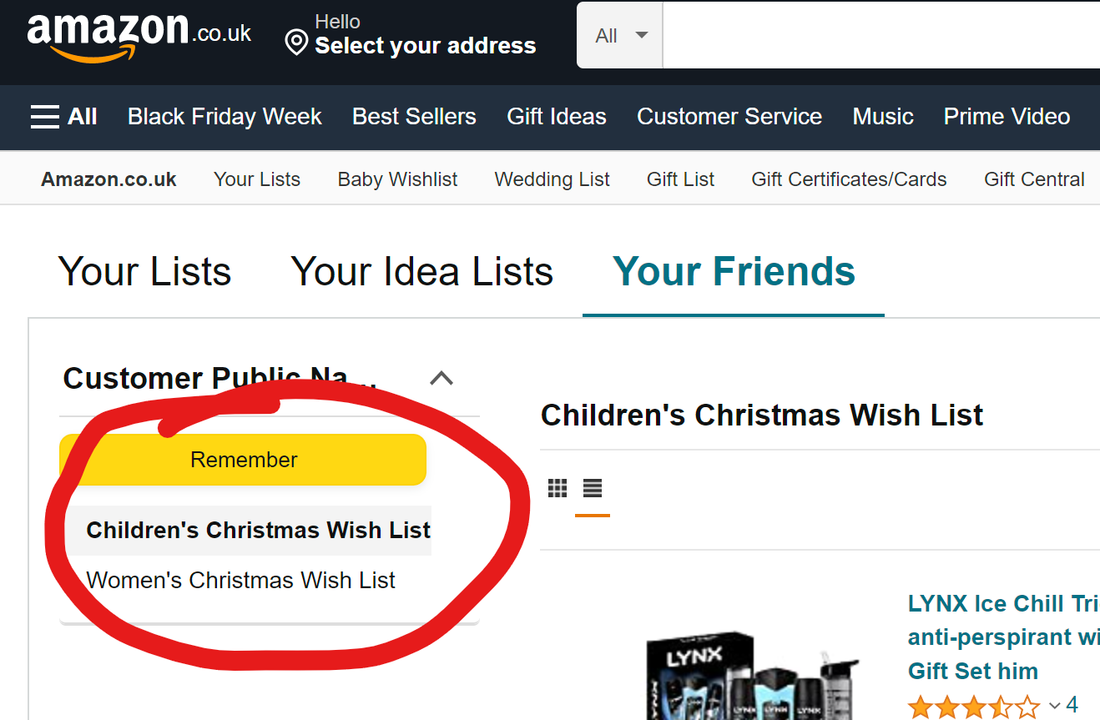
- Scrolling through wishlist, when you find the gift or gifts you want to purchase, click on the yellow “Add to Basket” button on the right side of the item
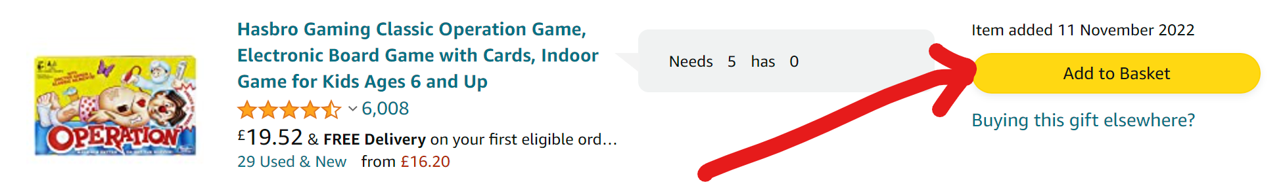
- If, after you have added gifts to your basket, you want to see your basket to checkout, the basket button is at the top right of your screen.
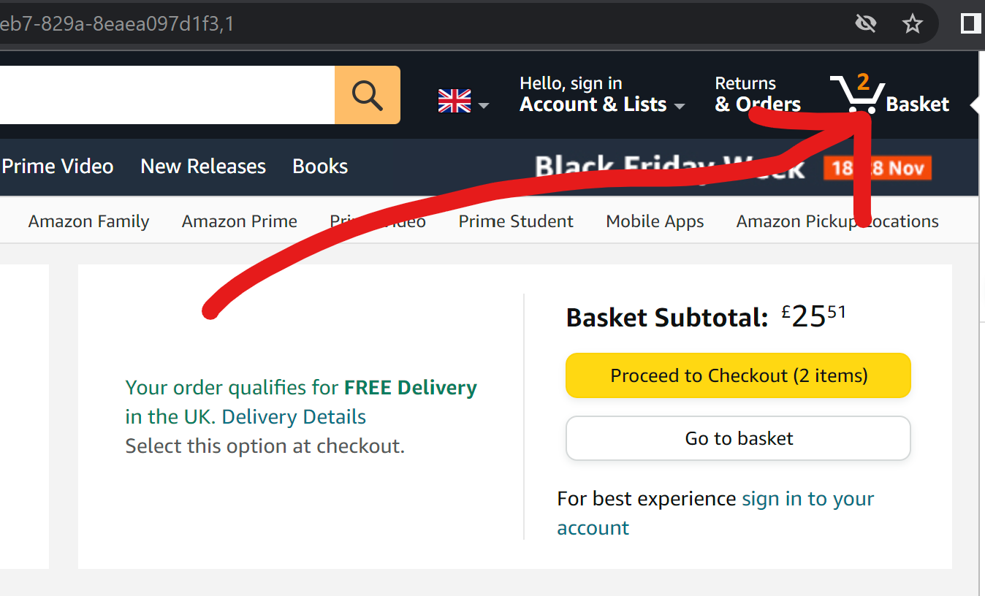
- Once you’ve added all the gifts you’d like to buy to your basket, you can proceed to checkout.
- At this point, you will either need to log in to your Amazon account or create one.
- Once you’re logged in to your Amazon account, you will need to select a delivery address. You MUST choose the once titled “sophie sophie’s Gift Registry Address”, and click the yellow “Use this address” button at the top right side.
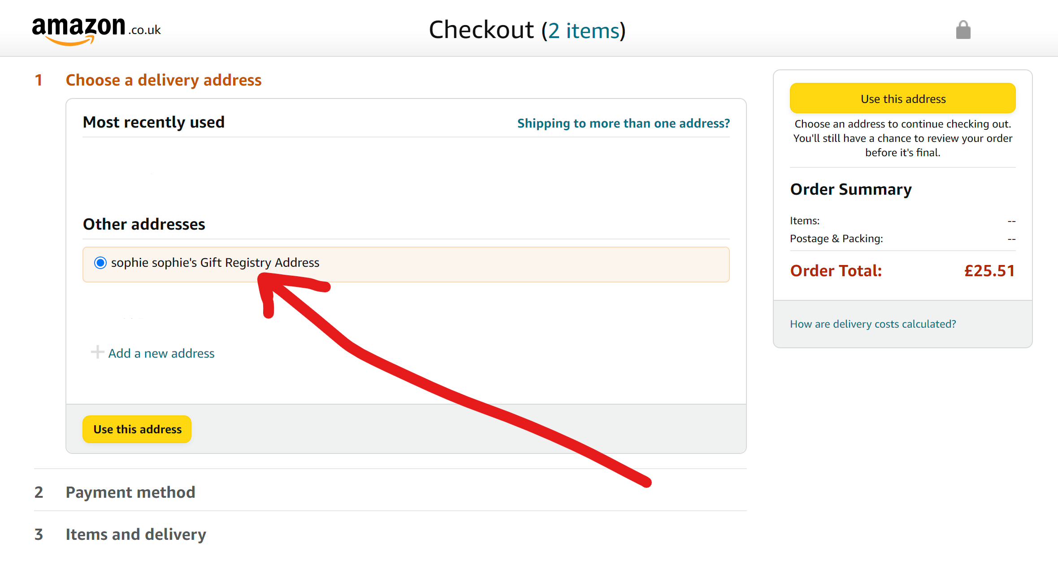
- Then you must add a payment method to purchase your gifts
- Then you must select a delivery method. However, before moving on from this step, it is important to click the “Add gift options”
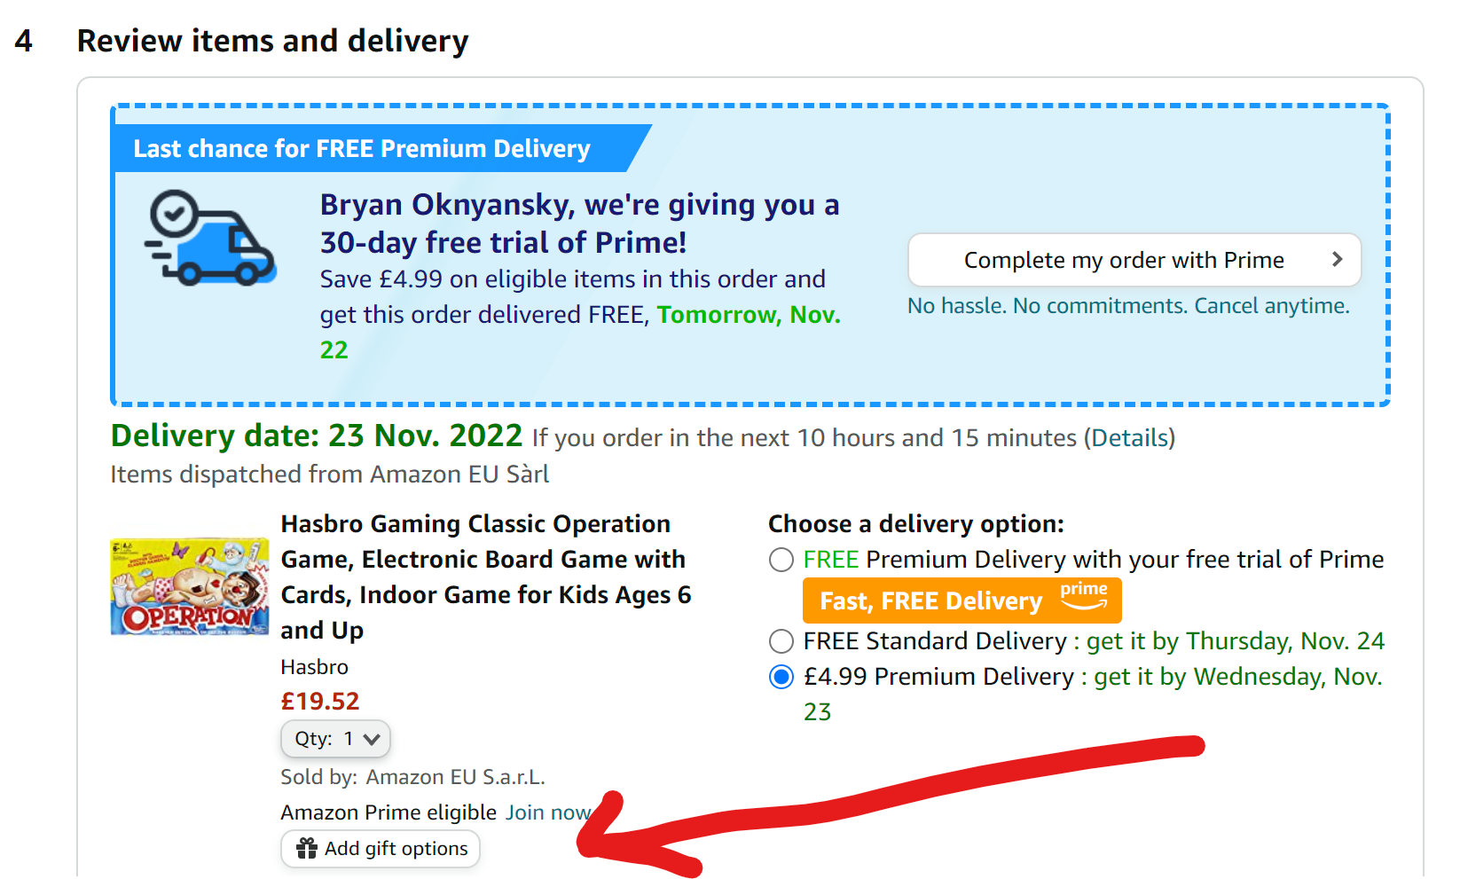
- In the “Gift message” box that pops up, please type in “Pattenmakers” in the “From” field where you put your name so the charity knows it’s from us! Then tick the box to email a receipt to the recipient. Finally, click the yellow “Save gift options and continue button at bottom-right.
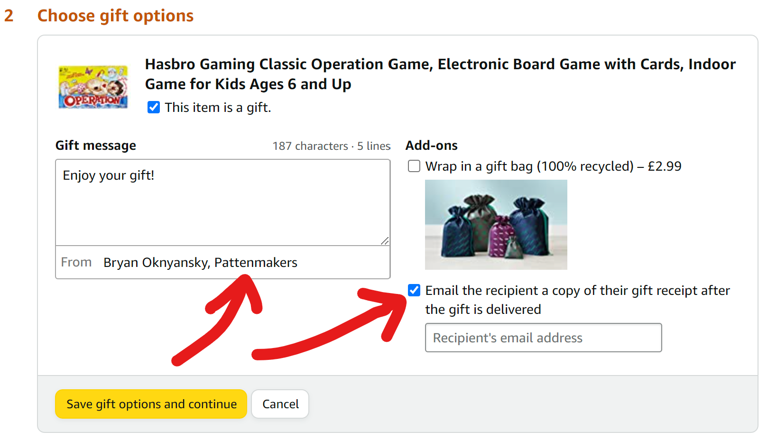
- Finally, click the yellow “Buy now” button either at the bottom or top-right of the webpage.

Thank you for your generous gift!
The Young Pattenmakers

