

REQUEST FOR INVITATIONS SPONSORED BY
BOOKING FORM
Young Pattenmakers Dinner 2022
Saddlers’ Hall,

40 Gutter Lane, London EC2V 6BR
Friday, November 18th 2022

First Name......................................................... Surname.............................................................

Post Nominals..................................................

Address......................................................................................................................................

I have the following dietary requirements:..........................................................................

I confirm that I am under the age of 40: Yes/No* please see below
The event including Reception, Dinner and Stirrup Cup is free courtesy of the Pattenmakers to invitees under the age of 40.
* I am over 40 and wish to attend. I enclose a cheque for £125.00 in payment for the event
Guests:
Please name your guest(s) below as you would wish the invitation to be worded

Name of Guest: ………………………………….………………………………………………………..…..
Special dietary requirements: …………………………..……………………………………………………

Cheques should be made payable to Pattenmakers Events Limited
Or, I would like to pay by Electronic Bank Transfer:
(please quote your name, name of the account and date of event)
Pattenmakers Events Limited
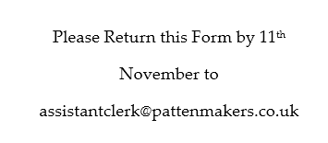
HSBC
Sort code 40-04-09
Account number: 71828924

