Annual Dinner for Facilities Management and the Built Environment
Tuesday, 18th October 2022
Apothecaries’ Hall, The Warehouse, 10 Black Friars Lane, London EC4V 6ER

Attending Host
Name:
Company name:
Special dietary requirements:
Drink preference: alcoholic non-alcoholic
E-mail:

I require ___ number of tickets at £125 each (incl. VAT)

Attending Guest(s)
If you are unable to confirm your Guest(s) details at present, please email it to us as soon as possible, but no later than by EOB on 11th October 2022.

Name:
Company Name:
Special dietary requirements:
Drink preference: alcoholic non-alcoholic

Name:
Company Name:
Special dietary requirements:
Drink preference: alcoholic non-alcoholic

Name:
Company Name:
Special dietary requirements:
Drink preference: alcoholic non-alcoholic

Seating Plan
Do you have a preference for seating arrangements?

Payment
Payments by electronic bank transfer should be made to:
Acc. Name: Pattenmakers Events Ltd
Sort code: 40-04-09
Acc. No.: 71828924
Please use your name and the event date (181022) as payment reference
Donation
We kindly ask you to please consider making a voluntary donation to the Pattenmakers’ Charitable Foundation. To make a donation by electronic bank transfer please pay to:
Acc. Name: Pattenmakers Charitable Foundation
Sort code: 40-04-09
Ac. No.: 31826166
quoting your name and the reference FMBE
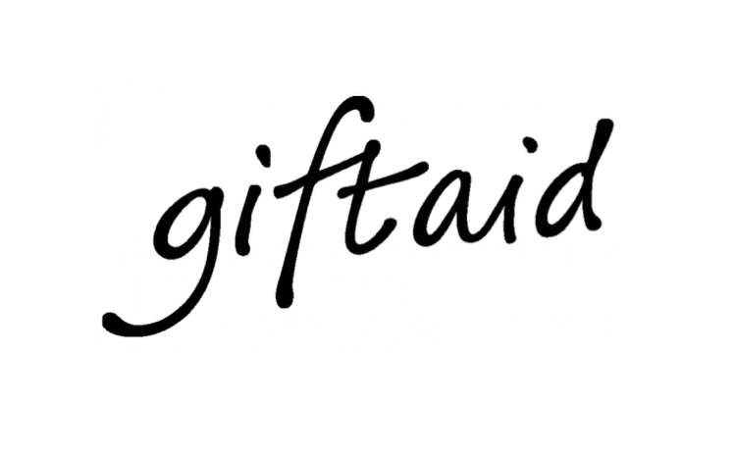
Gift Aid Declaration Form:
In order to Gift Aid your donation you must tick the box below. Your address is needed to identify you as a current UK taxpayer. Fields market * are key criteria for gift aid.
Please treat the donation I make to Pattenmakers’ Charitable Foundation as Gift Aid donation until I notify you otherwise. I am a UK taxpayer and understand that if I pay less Income Tax and/or Capital Gains Tax than the amount of Gift Aid claimed on all my donations in that tax year, it is my responsibility to pay any difference. I understand that Pattenmakers’ Charitable Foundation will reclaim 25p of tax on every £1 that I give. Gift Aid is reclaimed by Pattenmakers’ Charitable Foundation from the tax I pay for the current tax year.
First name and surname*
Full home address incl. post code*

Date*
Form Submission
Please return this form electronically to: pattenmakers@bwa.uk.net

Alternatively please post it to Monika Nawrot, BWA (Europe) Limited, 1st Floor, Alliance House, 29 London Road, Bromley, BR1 1DG. If you have any queries please contact Monika at the above email address or by calling 0208 460 1111.

