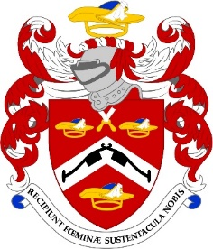

THE COMMON MEAL

THURSDAY, 22nd SEPTEMBER 2022

This year the Common Meal will be at
The City Livery Club
42 Crutched Friars
London
EC3N 2AP

NAME ………………………………………………………………..…

I enclose my cheque for ……………… or I have paid on line ...…

(please quote your name and the event)

Pattenmakers Events Limited
HSBC
Sort code 40-04-09
Account number 71828924

Dietary requirement ……………………………………………………

Please note tickets are not usually sent out but if you want to bring a potential member please let me know and I will send a card pour memoire

