Report from the first Annual Livery Climate Action Group Conference 4th July 2022
As Master I represented the Pattenmakers at this inaugural event held at the Merchant Taylors Hall on the 4th July.
The assembled group was welcomed by Alderman Sherriff Alison Gowman who gave some statistics as to why actions taken now to mitigate the effects of climate change, will pay huge dividends in the future. There are currently 50 Livery companies who have signed up as members of the group and this number looks set to grow. The website: https://liverycag.org.uk/about/ offers up news and events, blogs, and helpful advice and guidance notes on how to start to make a plan for change.
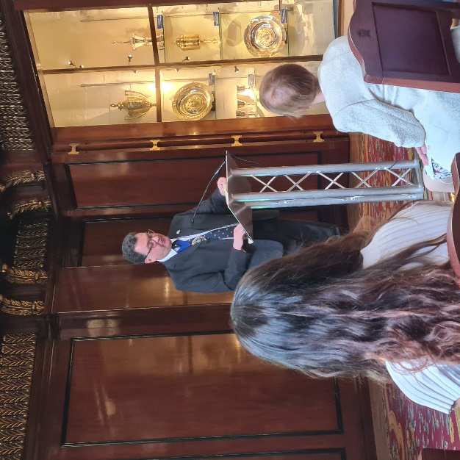
Also present to introduce the afternoon was The Lord Mayor Vincent Keaveny who reiterated the City’s target of net zero across every sector in the City by 2040. This objective is coupled with the establishment of the Green Finance Institute and the need to help developing countries which need a transition from an economy based on coal to one based on renewable energy. In the City, Stationers’ Hall has an air source heat pump system installed in its recent refurbishment, which is expected to give a significant reduction in heating costs: an excellent step and an example for other heritage buildings; and one which others are following. He also mentioned an example of how actions taken have improved air quality for residents in the Square Mile – since 2013 the air quality around the Barbican has improved by some 40%! The Corporation is looking to buy only green energy and to creating zero emission zones. He recognised that the Livery movement represents a large of number of trades and sectors all of whom will be or already are, looking to act and engage with climate activities and actions.
Food and the Livery Halls – Clare Clark, Head of Sustainability, CH&Co
We heard from Clare who gave a detailed presentation on sustainable catering. The UK has the third cheapest food in the world, with, on average, UK households spending approximately only 8% of their income on food – the 3rd lowest cost behind the US and Singapore. This came about apparently due to a post war push to ‘dig for Britain’ and the use of fertilisers. As most food depends on the soil from which it comes, herbicides and pesticides have, since the 1940s, helped to increase yields but have also impacted on the health of soil. Production of food accounts for over a quarter of our Green House Gas emissions, with emissions from food waste more than from aviation. The split of emissions for food is 18% from the supply chain, 31% from livestock and fisheries, 27% in crop production and 24% in land use. Overall emissions can be reduced by the use of diverse ingredients, seasonal crops, and more food from plants. Emissions can also be reduced by reducing waste and avoiding the use of air freight.
Here in the UK we have lost our connection with food. It is relatively cheap, yet, despite paying the lowest for our food in Europe we hear that 2.5 million people (possibly higher) are accessing foodbanks. The food sector employs 4 million people (one of the largest employment sectors in the UK) but we also pay very low prices to farmers which has meant investment has suffered. Home economics has dropped off the curriculum and we waste one third of all our food.
The actions Clare suggests that individuals can take include reducing waste, eating seasonal produce with more plant based ingredients and setting refrigerators at +4°C being a couple of simple ones. Also, Livery Companies can be bold with menus, flex to the seasons, and update Hall equipment.
Breakout Sessions:
The attendees were then split into 2 groups and in turn attended break-out sessions on:
- Building a Livery Company Climate Action Plan
- Benchmarking and baselining carbon footprints
For both of these areas there is a lot of useful information available on the website – which hopefully we, as Pattenmakers will use to come up with our own plan in due course.
The ESG Business Case – presented by:
Flora Hamilton, Director of Financial Services, CBI and
Victoria Hoskins, Investment Director, Rathbone Greenbank Investments
ESG investors look for companies planning to achieve net zero targets. New regulations for charities will be a challenge on ESG governance for which there is some guidance on the LCAG website.
Risks include climate risk of drought and flooding; risks to supply chains and people; cost of disruption; risks to insurance; risk of stranded assets; reputational risk in mitigating climate change; and the potential need to divest of some investments. Major energy companies: BP, Shell, Equinor (previously Statoil) and Ørsted (previously DONG) and others are divesting from carbon to green industries and considering alternative fuels such as hydrogen.
Opportunities include reducing current emissions; disclosure of emissions; decarbonisation strategies, and allocation of CAPEX to reach net zero. Some companies may achieve net zero by 2030 or 2040.
Refurbishment of Listed Livery Halls and Buildings
Derek Farrow, Worshipful Company of Constructors
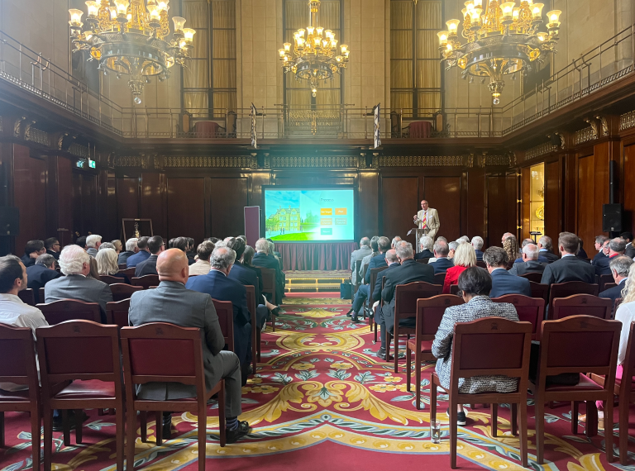
Finally, we heard from Derek about how to tackle the refurbishment of listed buildings – which applies to most of the existing Livery halls. While we do not have a Hall, we do have a responsibility for St Margaret Pattens. There are many sources of guidance available including on the LCAG website and Derek gave lots of insights and helpful tips to all present.
In summary, this was a very informative conference and well worth attending. The plan is for it to become an annual event – and certainly the atmosphere amongst attendees was one of how we can learn from each other, advice on simple actions we can take as individuals as well as guidance for those with property and/or wishing to set up an action plan.

