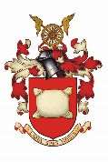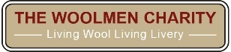
2022 Sheep Drive and Livery Fair Sunday September 25th London Bridge
2022 Sheep Drive Bookings are now open
Calling all Liverymen and Freemen:
The Lord Mayor and special guest “Harlequin” - a cross-breed ewe from City Farm, The Woodlands Farm Trust - today officially announced the opening of bookings for The Woolmen’s annual Sheep Drive. This ewe-nique annual City event will be held on London Bridge in 2022, with a magnificent Livery Fair located nearby at The Monument.

Charity Sheep Drive:
Bookings for places for Freemen and their guests can be made on line here: https://sheepdrive.london/ where full details of the event can be found.
Access to the Sheep Drive, which will occupy the downstream walkway on London Bridge, is restricted to the 1,000 plus pre-booked Freemen of the City of London and their guests, with the remainder of the bridge open to vehicular and pedestrian traffic.
This great livery occasion will once again be in aid of the Woolmen’s Charity and Lord Mayor’s Appeal. Hurry as bookings have previously quickly sold out!

If you are making a booking for a group larger than 10 people, please contact sheepdriveteamenquiries@woolmen.com to discuss your requirements.

Livery Fair: at The Monument. Free to all
Join us at the wonderful Livery Fair, located at the north end of London Bridge on the piazza adjacent to The Monument - one of the City's most loved visitor attractions.
We are delighted to be welcoming back many livery companies who have joined us in previous years and look forward to welcoming many more.
The Livery Fair will also include specialist wool trade and craft stalls. Other fun activities will include expert blade shearing displays and some wonderful rare breed sheep! To find out more and secure your place, please contact: info@SquareEvents.co.uk

Peter Hullah, Master of The Worshipful Company of Woolmen:
“This eagerly-anticipated charity event in the Livery calendar returns to London Bridge for 2022. The Woolmen organise our unique charity fundraising event for all Freemen of the City of London, their families and friends. We look forward to welcoming many livery company members to drive sheep over the Thames and to join us for a marvellous Livery Fair at The Monument. This is sure to be a vibrant and fun day out in the City with the chance to delve into the fascinating history of the livery trades, alongside wonderful wool stalls and even a few sheep… A fantastic family day out.”

The Rt. Hon. The Lord Mayor, Alderman Vincent Keaveny:
“As Lord Mayor and as a liveryman of the Worshipful Company of Woolmen, I am delighted to be taking part in this year’s Sheep Drive and visiting the Livery Fair. I would like to thank the Freemen, Livery Companies, The Campaign for Wool and all our sponsors raising funds for the Woolmen’s Charity and Lord Mayor’s Appeal. The Sheep Drive and Livery Fair remind us all that the link between City and Wool remains as important to us today as it has ever been.”

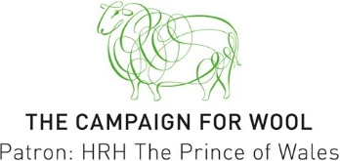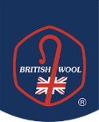

Headline Sponsor Sponsors:

