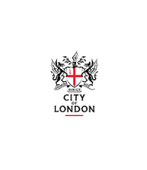
Trades House of Glasgow
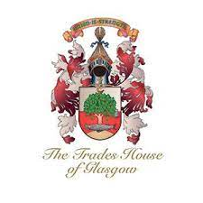
THE GLASGOW IN
LONDON DINNER

Tuesday 6th September 2022

Plaisterers’ Hall

May 2022

Dear Master/Upper Warden/ Bailiff

I would like to draw your attention to this very special and fun event which takes place each year. The dinner promotes the relationship between the London Livery Companies and their equals in Glasgow, the Trade Incorporations, of which there are 14. It is attended by members of the Trade Incorporations that live in the South of England and leaders of the Incorporations from Glasgow known as the ‘Chain Gang.’ The event is presided over by the Deacon Convener of the Trades of Glasgow who is also Glasgow’s Third Citizen. An invitation is extended to the Lord Mayor Nominate or a Sheriff who replies to the toast to the City of London. A feature of the event is the Visitation which is made by distinguished visitors who are escorted into the room to music. It is combined with a toast to the City of Glasgow and the Trades House before being escorted out to singing. The event includes a Piper, traditional songs and informal toasts which give it a unique flavour and less formality than a livery banquet.

Some Livery Companies already have formal relations with Glasgow Incorporations but the event is open to representatives of all London Livery Companies.

I am an Ex-Deacon of the Incorporation of Bonnetmakers and a member of the organising committee and a regular attendee at the dinner. I hope that you and indeed any member of your company and partners will join us at this event. Application details are separately attached.

Yours sincerely

Christopher Hayward CC
Chairman, Policy & Resources Committee
City of London

Organising Committee: Keith Brown OBE, Joanna Emms, Dorothy Newlands of Lauriston, Christopher Hayward CC, Gordon Masterton

