

Dinner at London Zoo
WEDNESDAY 8th June 2022
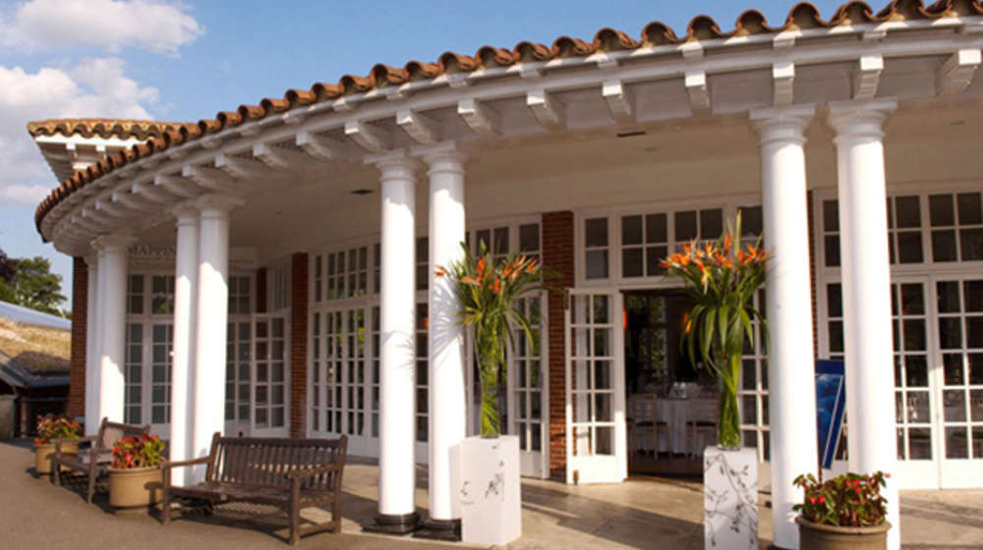

From:
Title …… Name: …………………………………………………….….. Post Nominals: ……………….….
Special dietary requirements: ……………………………...……………………..………………………….…
Address: …………………..…………………………………….……………………………………………….
Name of Guest: ………………………………………………………….……………………………………......
Special dietary requirements: ……………………………...……………………..………………………….…
I require: …….. (no) tickets at £98.00 each

To pay by electronic bank transfer please quote your name and date of event (08/06/22) to:

Pattenmakers Events Ltd
Bank: HSBC Sort code: 40-04-09 Account number: 71828924
IBAN: B26HBUK40040971828924 BIC: HBUKGB4106D

Cheques should be made payable to: Pattenmakers Events Ltd.

To reserve your place, please return this form before the 1st June to the Assistant Clerk:
Email: assistantclerk@pattenmakers.co.uk
Post: Hydewood Cottage, Hydewood Road, Little Yeldham, Essex, CO9 4QX

Please note that cancellations after the 1st of June will be non-refundable

