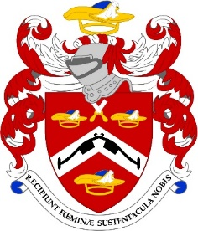

Dear Company Member 24th May 2022
COMMON HALL - Election of Sheriffs – Friday, 24th June 2022

There are tickets available for the election of the Sheriffs on Friday, 24th June 2022 at the Guildhall. This is an ancient privilege for Liverymen of the City of London since medieval times to elect the Sheriffs for the ensuing year. If you would like to vote, please let me know as I have to send you a ticket. Please remember that only Liverymen admitted to the Company before July 2021 are entitled to vote. The Founders’ Company has been kind enough to invite us to join them for lunch at their Hall. The cost of the two course luncheon including wines is £50.00 per head. This is an effort to provide more affordable events in the City at this time. Please return the attached slip to me as soon as possible if you would like to attend. You do not have to have voted to attend the luncheon!

Please return the attached form as soon as you are able and, as always, please visit the website www.pattenmakers.co.uk and check that your information is correct and current!

With best regards

Robert Murfin
COMMON HALL – ELECTION OF SHERIFFS

I would like to attend Common Hall on Friday, 24th June 2022

Please reserve me ………………. places for luncheon and I enclose my cheque for ………………… (£50.00 per head) or I have paid on line
Pattenmakers Events Limited
HSBC
Sort code 40-04-09 Account number 71828924

NAME ……………..………….…………………..……………………………..

I will be accompanied by …………………..……………………………………
Please return to the Clerk as soon as possible

