CHAMBERLAIN’S COURT UPDATE 13.04.2022

Ceremonies:
At present we are still dealing with a large backlog of applicants awaiting ceremonies and the numbers coming through both Courts have returned to pre-pandemic levels. As a result, we are currently fully booked until mid-July with little wriggle room. I anticipate this situation will continue until a new Deputy Clerk has been appointed. When this happens, we should be able to release more slots and examine strategies to deal with any bottlenecks in admissions. Until then it might be wise not to book Freemen into Clothing ceremonies until you know they have obtained their Freedom of the City. It is a far from ideal situation but with the best will in the world there are only so many ceremonies I can personally conduct! We are keeping the wheels moving and I hope that things will improve soon, in the meantime I can only ask you all to bear with us.

Applications
There are no more application interviews here at Guildhall, but we are still being routinely contacted by people asking to do so. I have attached the current application form to the email accompanying this newsletter. This includes the BACs transfer details for payment of the fee. Please stress the need to answer all sections of the form and attach the required documents, not doing so delays applications as we do not have the resources to repeatedly chase-up missing information.
Patrimony and Servitude applications need to be submitted and fees paid for in good time, the Calligrapher requires all names for the following week’s ceremonies by the previous Thursday morning.

Fees
A reminder that these went up to £150 on the 1st of April – everyone should have received an email from Murray Craig notifying them of the increase. Please amend your information accordingly. Those who applied after the 1st of April and who pay the old fee will be contacted and asked to remit the difference.

Communicating with us
Our contact emails are below, I would suggest using these rather than the telephone for now, as current staffing levels mean we are often not in the office or unable to answer the telephone – a situation that is, once again, hopefully temporary. A telephone conversation is rarely needed but if it is, let me know via email and I will call you.

Application forms and requests for ceremony bookings should be sent to the Court Assistant: Tiphaine LeBian: Tiphaine.LeBian@cityoflondon.gov.uk
You may also hear from our Business Apprentice, Lewis Dance: Lewis.Dance@cityoflondon.gov.uk
For enquiries about frames, purchasing merchandise and ceremony arrangements on the day our Beadle, Danny Herbert, can be contacted at Daniel.Herbert@cityoflondon.gov.uk he may be contacted on the day of a ceremony on 0207 3321353
I can be contacted at: Laura.Miller@cityoflondon.gov.uk

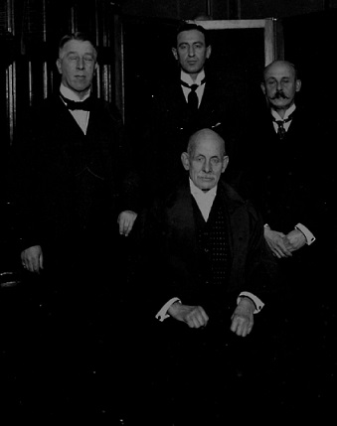
A photograph of the Chamberlain’s Court staff circa 1924

