

LIVERY DINNER IN THE
HOUSE OF LORDS
WEDNESDAY, 23rd FEBRUARY 2022

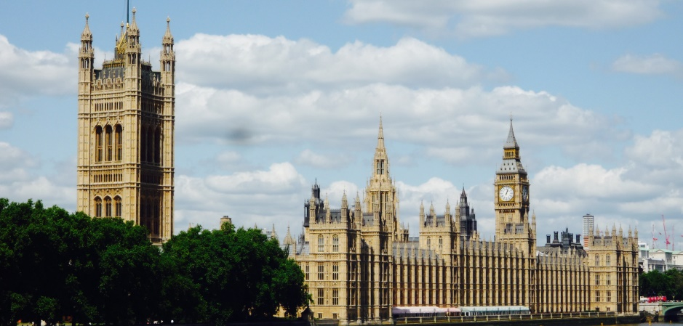
From:
Title …… Name: …………………………………………………….….. Post Nominals: ……………….….
Special dietary requirements: ……………………………...……………………..………………………….…
Address: …………………..…………………………………….……………………………………………….
Guest Names: ………………………………………………………….……………………………………......
……………………………………………………………
(Further names please use the reverse of this form)

I require: …….. (no) tickets at £105 each and enclose my cheque for £ ………………

Cheques should be made payable to: The Pattenmakers Company Charitable Foundation
OR I will pay by electronic bank transfer (please remember to quote your name (above) and date of event to:
The Pattenmakers Company Charitable Foundation
HSBC
Sort code: 40-04-09
Account number: 31826166
IBAN: GB56HBUK40040931826166
BIC: HBUKGB4106D

Please return this form to the Master as soon as possible and in any event before
16th February 2022
master@pattenmakers.co.uk

Please note that cancellations after this date will be non-refundable

