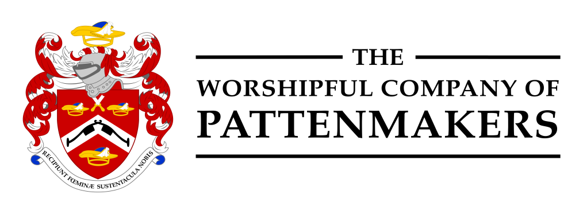

LIVERY DINNER AT THE
HOUSE OF COMMONS

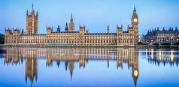

WEDNESDAY, 15th DECEMBER 2021
From:
Title …… Name: …………………………………………………….….. Post Nominals: ……………….….
Special dietary requirements: ……………………………………………………..………………………….…
Address: ……………………..…………………………………….………………………………………..
…………………………………………………………………………….………………………………………..

I require …….. (no) tickets at £98 each and enclose my cheque for ………………

Cheques should be made payable to: Pattenmakers Events Ltd
OR I will pay by electronic bank transfer (please remember to quote your name (above) and date of event to:
Pattenmakers Events Ltd
Sort code: 40-04-09
Account number: 71828924
IBAN: GB26HBUK40040971828924
BIC: HBUKGB4106D

Please return this form to the Master as soon as possible and in any event before
10th December 2012
master@pattenmakers.co.uk

