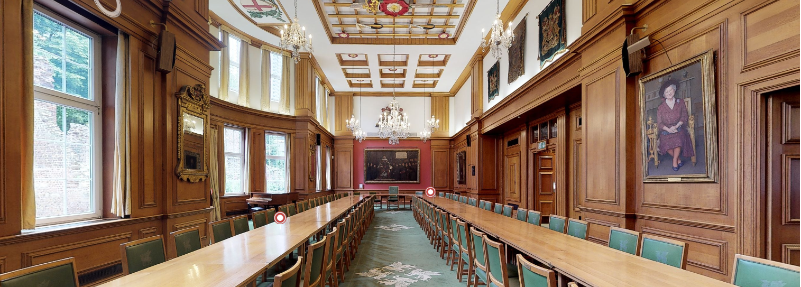
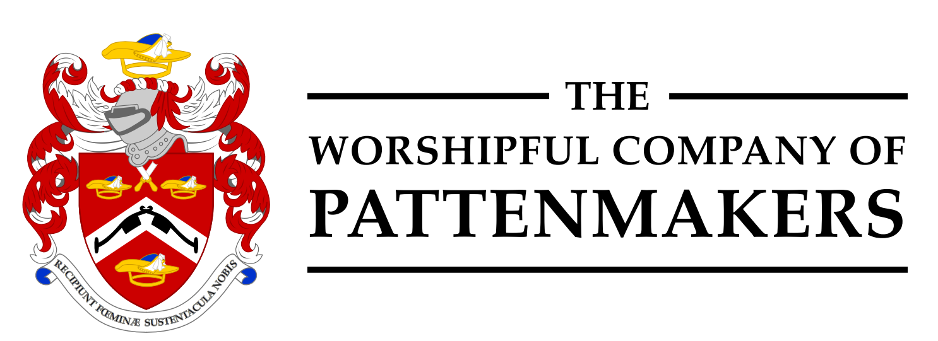
INVITATION
Young Pattenmaker Eleventh Annual Dinner
Friday 26th November 2021
6.30pm – 7.00pm. Carriages 10.30pm
Barber-Surgeons’ Hall – click for the virtual tour
Monkwell Square, Wood Street, London EC2Y 5BL
Dress: Black Tie or Lounge Suit. Ladies: Cocktail or Smart
Dear Friends
We are pleased to announce that the Eleventh Annual Young Pattenmakers' Dinner will be held on Friday, 26th November 2021, at Barber-Surgeons' Hall in the City of London.
The Dinner for Young Pattenmakers is an annual Livery dinner held by The Worshipful Company of Pattenmakers that enables young professionals under the age of 40 to experience aspects of the social and fellowship sides of the City, and to learn about the benefits and pleasures of being part of one of the ancient Livery Companies of the City of London.
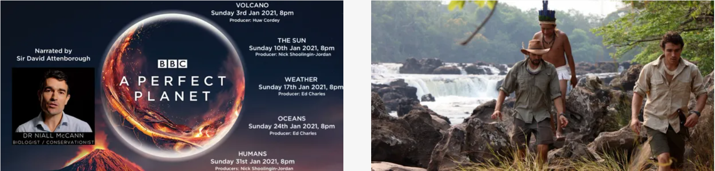

This year we are delighted to welcome Dr Niall McCann, an explorer and Biologist as our guest speaker. Since the age of 18 Niall has undertaken challenging expeditions all over the world and conducted remote-area biological research specialising in endangered species. His adventures have been covered in the media for many years. He worked alongside Sir David Attenborough on the BBC’s A Perfect Planet and presented the award-winning PBS documentary Lost in the Amazon: the enigma of Colonel Percy Fawcett.
If you would like to join us for the evening and find out more about the Young Pattenmakers
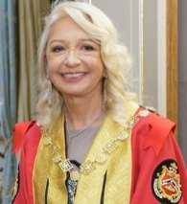
please complete the attached form and return it no later than 17th November 2021.
Master Jennifer Bryant-Pearson
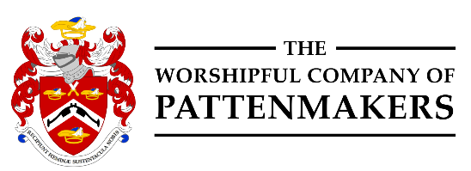
REQUEST FOR INVITATIONS Lead Sponsors:

BOOKING FORM
Young Pattenmakers Dinner 2021
Barber-Surgeons’ Hall,

Monkwell Square, Wood Lane, London EC2Y 5BL
Friday, November 26th 2021
6.30pm – 7.00pm. Carriages 10.30pm

First Name......................................................... Name.............................................................

Post Nominals..................................................

Address......................................................................................................................................

I have the following dietary requirements:..........................................................................

I confirm that I am under the age of 40: Yes/No* please see below
The event including Reception, Dinner and Stirrup Cup is free courtesy of the Pattenmakers to invitees under the age of 40.
* I am over 40 and wish to attend. I enclose a cheque for £98.00 in payment for the event
Guests:
Please name your guest(s) below as you would wish the invitation to be worded
Name of Guest: ………………………………….………………………………………………………..…..
Special dietary requirements: …………………………..……………………………………………………
Supporting Sponsors

Cheques should be made payable to Pattenmakers Events Limited

Or, I would like to pay by Electronic Bank Transfer:

(please quote your name, name of the account and date of event)
Pattenmakers Events Limited
HSBC
Sort code 40-04-09
Account number: 71828924

