TICKET REQUEST
350th Anniversary Dinner

Tuesday, 21st September 2021
The Guildhall
Basinghall Street, London EC2V 7HH

6.45pm for 7.15 pm. Carriages 10.30pm
Black Tie & Decorations

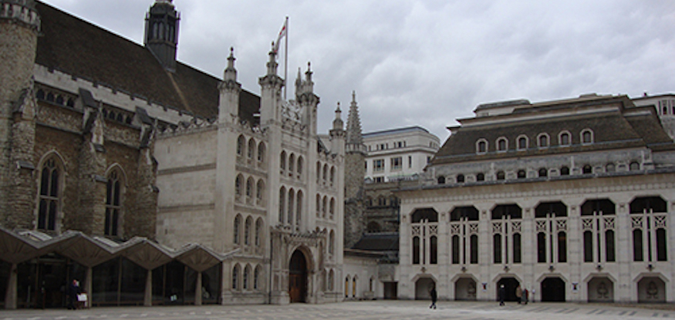

To: R W Murfin, 3 The High Street, Sutton Valence, Kent. ME17 3AG

Name.............................................................................................. Post Nominals ...................
Address........................................................................................................................................
....................................................................................................................................................
I wish to attend alone/with the following guest and I enclose a cheque for £......................... in payment for Qty 1/2 invitations at £100.00 per person.
Name of Guest ……………………………………………………………………………………………………………….………………….
Dietary Requirement (s)…………………………………………………………………………………………………………………….
For additional tickets, please complete next page

Cheques should be made payable to Pattenmakers Events Limited
or, I would like to pay by Electronic Bank Transfer:
(please quote your name, name of the account and date of event)
Pattenmakers Events Limited
HSBC
Sort code 40-04-09
Account number: 71828924

NAME:
I wish to apply for additional tickets qty …………… at £125.00 per person Total £ ……………….…….

Name of Guest ....................................................................................................................................
Dietary Requirement ...............................................................................................................................

Name of Guest ………............................................................................................................................
Dietary Requirement ...............................................................................................................................

Name of Guest ………….........................................................................................................................
Dietary Requirement ..............................................................................................................................

Name of Guest ………….........................................................................................................................
Dietary Requirement ..............................................................................................................................

Please list additional guests, addresses and seating requirements below.

PLEASE RETURN THIS FORM TO THE CLERK
Please note that cancellations seven days before the event are non refundable

