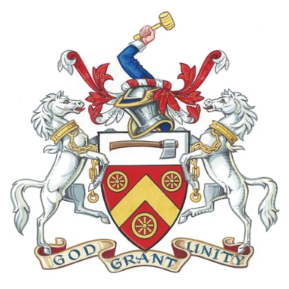
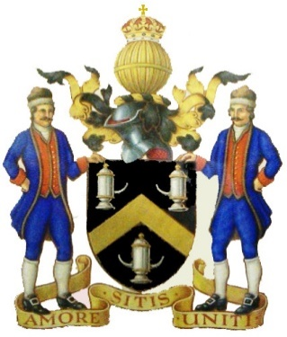
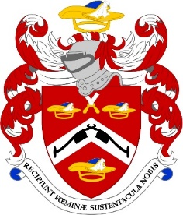

350th Anniversary
of the Grant of the Pattenmakers’ Company
First Royal Charter by King Charles II
2020 was the 350th anniversary of our first Royal Charter and we had plans to mark the occasion at the Guildhall with the other two Companies who shared that anniversary, the Wheelwrights and the Tin Plate Workers. Although we were not able to meet as planned last year, we are very pleased to be jointly celebrating that special event this year instead
Please join us on 21st September for our anniversary celebration when all three Livery Companies will get together in style for a dinner at the Guildhall and we will be honoured with the attendance of the entire Civic Party
Tickets for this special black tie event would normally be £125 but the Company is supporting the dinner to reduce the price to £100 for members and one guest. Additional guests will be charged the full rate.
I very much hope that you will wish to attend and as places will be limited, please let the Clerk know as soon as possible
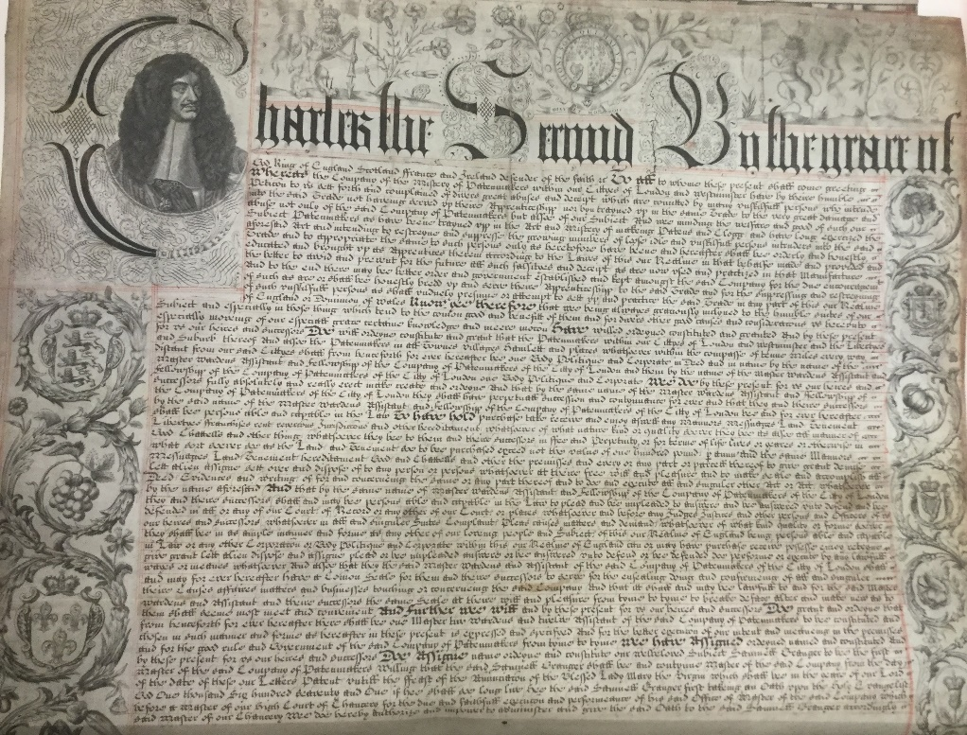
Best wishes
Jennifer
Master Pattenmaker

1670

TICKET REQUEST
350th Anniversary Dinner

Tuesday, 21st September 2021
The Guildhall
Basinghall Street, London EC2V 7HH

6.45pm for 7.15 pm. Carriages 10.30pm
Black Tie & Decorations

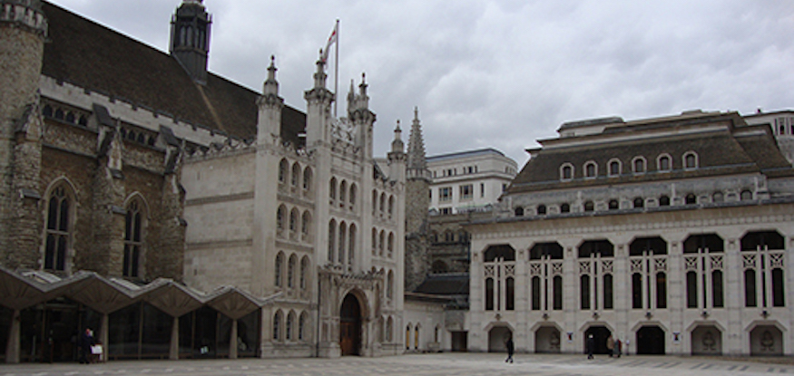

To: R W Murfin, 3 The High Street, Sutton Valence, Kent. ME17 3AG

Name.............................................................................................. Post Nominals ...................
Address........................................................................................................................................
....................................................................................................................................................
I wish to attend alone/with the following guest and I enclose a cheque for £......................... in payment for Qty 1/2 invitations at £100.00 per person.
Name of Guest ……………………………………………………………………………………………………………….………………….
Dietary Requirement (s)…………………………………………………………………………………………………………………….
For additional tickets, please complete next page

Cheques should be made payable to Pattenmakers Events Limited
or, I would like to pay by Electronic Bank Transfer:
(please quote your name, name of the account and date of event)
Pattenmakers Events Limited
HSBC
Sort code 40-04-09
Account number: 71828924

NAME:
I wish to apply for additional tickets qty …………… at £125.00 per person Total £ ……………….…….

Name of Guest ....................................................................................................................................
Dietary Requirement ...............................................................................................................................

Name of Guest ………............................................................................................................................
Dietary Requirement ...............................................................................................................................

Name of Guest ………….........................................................................................................................
Dietary Requirement ..............................................................................................................................

Name of Guest ………….........................................................................................................................
Dietary Requirement ..............................................................................................................................

Please list additional guests, addresses and seating requirements below.

PLEASE RETURN THIS FORM TO THE CLERK BEFORE
7th September 2021
Due to printing deadlines not through this office!
It is recommended you book early as this event is expected to be well subscribed
Please note that cancellations seven days before the event are non refundable

