
FACE MASK ORDER FORM
Please send me . . . . . Pattenmakers’ Face Mask(s)
At £15.00 each including postage & packing (UK only)
(including a donation to the Pattenmakers’ Charitable Foundation)
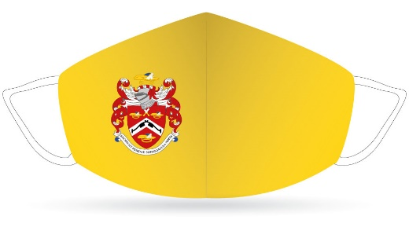
Masks come with an anti-microbial lining and are washable
NAME ………………………………………..………………….………………
ADDRESS ………………………………………………….……………………
……………………………………………………………………………………
……………………………………………………………………………………
Please find enclosed my cheque for ……………..… or I have paid on-line

The Worshipful Company of Pattenmakers

HSBC Sort code: 40-04-09 Account number: 01828606

and return the form to

clerk@pattenmkers.co.uk or post to

RW Murfin TD DL

3 The High Street

SUTTON VALENCE
Kent

ME17 3AG

