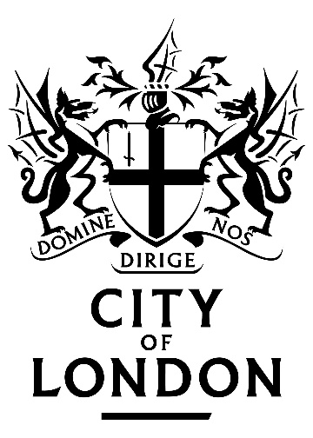
Pattenmakers Dinner
Egyptian Hall
Thursday 23rd January 2020
Lord Mayor Locum Tenens
Alderman Sir David Wootton

Master, Wardens, Sheriff, Ladies and Gentlemen

Master, thank you for that generous Civic Toast, and on behalf of myself, my wife Liz, Sheriff – and Past Master – Chris Hayward and his wife Alex, may I thank you for your warm words of welcome, and thank you all for your hospitality this evening and

may I wish all of you and your families a very happy new year.

I’m delighted to be back among with the Pattenmakers, especially at this early time of year, when the nights are long, frost is spreading across the grass and the wind is piercing down the narrow streets of the City…

What better place to be among many people I know and admire…

I’m going to single out just two.

Past Master Tony Eskenzi CBE, past Chief Commoner of the City of London and his wife Eileen, Mrs Eileen Eskenzi MBE.

When I was first elected to the City Corporation, for the Ward of Farringdon Within, Tony was the Deputy of the Ward and took me under his wing. He taught me all I know. And what happened to me afterwards I put down firmly to the support and guidance which Tony and Eileen gave Liz and me.

I congratulate you, Master, on your excellent speech, and your characterisation of the opportunities for Livery companies to contribute to shaping the future of the City of London and its reputation.

I congratulate you, too, on being the head of such a progressive Company, as others will note that, having already had two women Masters, all today’s three Wardens are women.

I have come to think of you Pattenmakers as the Worshipful Company of Party Goers…

Every time I go to a party – wherever it is – the Pattenmakers are there before me!

Example: in April, many of us will be heading to Zurich for the Guilds Weekend the Sechseläuten…

that’s ‘Six bells’ in German…

a festival that denotes the coming of Spring.

This year the Lord Mayor and Lady Mayoress are going, as are Liz and I…

But I know that the welcoming party will be…the Pattenmakers, who are out in force each year.

A while ago, I was at my University alumni dinner, a great opportunity to catch up with some of my oldest friends…

And who should be assisting with the turnover of the bar when we all retired from dinner?

It was, of course, the Pattenmakers!

And I knew that this evening was going to be fun when I read the event running order produced by your excellent Clerk.

It begins, 5:45PM – Master, Wardens and escorts assemble and gown, 6:05 – photographs in Drawing Room, 6:15 – Large drink.
Now this might make you mistake the Pattenmakers for simply just the partying sort…

Do not be deceived: nothing could be further from the truth.

Because for a party to work there must be something serious at its heart.

Let’s look at those events again…

The Guilds Weekend is a party, yes, think of the Lord Mayor’s Show lasting four days…

But at its centre is an opportunity for the Guilds of Zurich to come together with each other and with their guests, which include many City Livery companies, to foster relations, both within the community of Zurich and internationally.

In the bar after the University Dinner, there was an excellent reason for the Pattenmakers to be there…

The following day was the Cambridge International Symposium On Economic Crime – a Symposium which your past Master Barry Rider founded, 39 years ago, and in running which your excellent Clerk Robert plays a major role…

And it has now become one of the most important annual speaking events for Lord Mayors.

We are at a party here tonight…but… look at the Awards just presented…

And your grants for those in need of orthopaedic footwear…

Or the work of your Past Master – Sir John Timpson – to provide jobs for ex-offenders…

The Pattenmakers – at their very heart – are doing serious work, and playing their role to ensure that the City’s reputation remains strong.

The Lord Mayor cannot be with us this evening because he is in Davos at the World Economic Forum – at which no doubt there are several parties – but it is actually a very serious occasion…

He has be joining international roundtables, discussing, for example, how the City’s financial and professional services are world leaders in green finance…

And how we are helping countries find sustainable ways of funding their infrastructure projects through our Green Finance Institute.

In his first 80 days, the Lord Mayor has visited the United States, Mexico and Abu Dhabi to spread this message, as well as highlighting the City’s expertise in innovation through financial technology and tackling cyber-crime.

But what he has enjoyed more is visiting different parts of the UK – Manchester, Leeds, Glasgow, Birmingham and Northern Ireland – recruiting the country’s most innovative business leaders to join him on his international visits.

He, too, is managing the reputation and the history of the City, ensuring that – despite whatever happens with Brexit – we have a strong and diverse economy…

And that our long-held position as the world leader in financial and professional services remains unchanged.

Yes, this is hard work but the Lord Mayor also recognises the importance of the fun and the generous side of the role…

Like the giving of gifts, as thanks for the Pattenmakers continued support for the Office of the Lord Mayor…

For you, Master, a mayoral mug of the finest bone china with a tin of specially blended peppermint tea grown in England at the Tregothnan estate in Cornwall.

And for your excellent Clerk – the customary Mansion House spoon.

Both mug and spoon are decorated with bees…

A reference to the Lady Mayoress’s work with the charity “Bees for Development” and to the reappearance of beehives on top of Mansion House!

Ladies and gentlemen, it is a pleasure for Liz, Chris, Alex and me to be here this evening With The Worshipful Company of Party-Goers with a very serious purpose…

And I wish you all the very best for 2020.

Thank you very much.

